SQL PROJECT
Project Title: E-Commerce Customer Churn Analysis
Problem Statement: In the realm of e-commerce, businesses face the challenge of understanding customer churn patterns to ensure customer satisfaction and sustained profitability. This project aims to delve into the dynamics of customer churn within an e-commerce domain, utilizing historical transactional data to uncover underlying patterns and drivers of churn. By analyzing customer attributes such as tenure, preferred payment modes, satisfaction scores, and purchase behavior, the project seeks to investigate and understand the dynamics of customer attrition and their propensity to churn. The ultimate objective is to equip e-commerce enterprises with actionable insights to implement targeted retention strategies and mitigate churn, thereby fostering long-term customer relationships and ensuring business viability in a competitive landscape.
Dataset Download:
https://drive.google.com/uc?export=download&id=1iKKCze_Fpk2n_g3BIZBiSjcDFdFcEn3D
Executed the given data
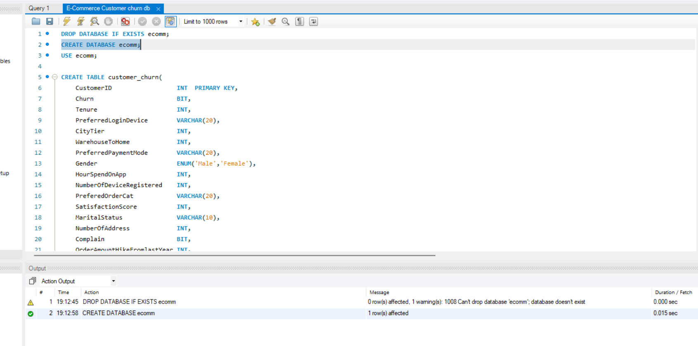

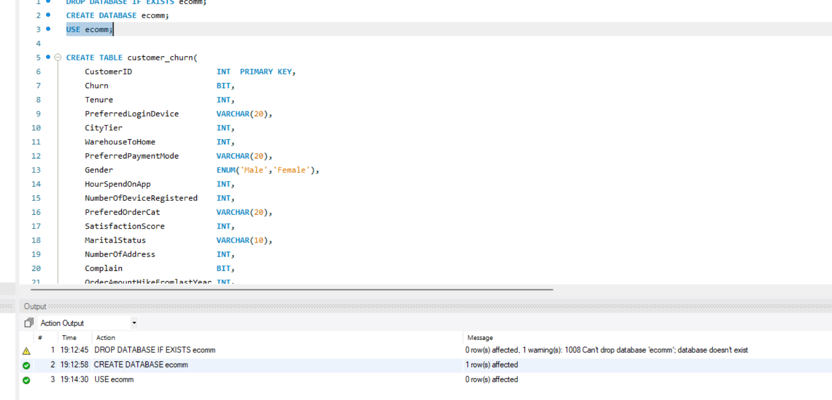

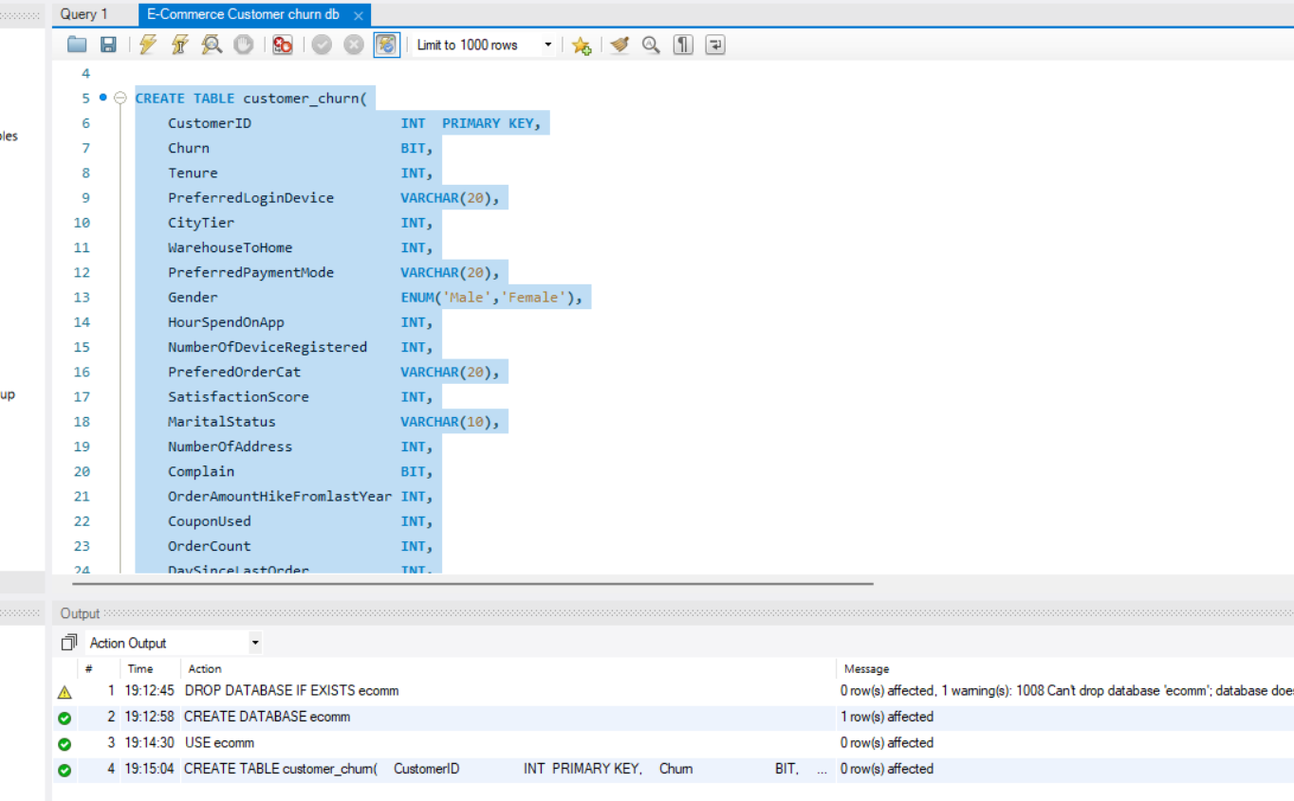

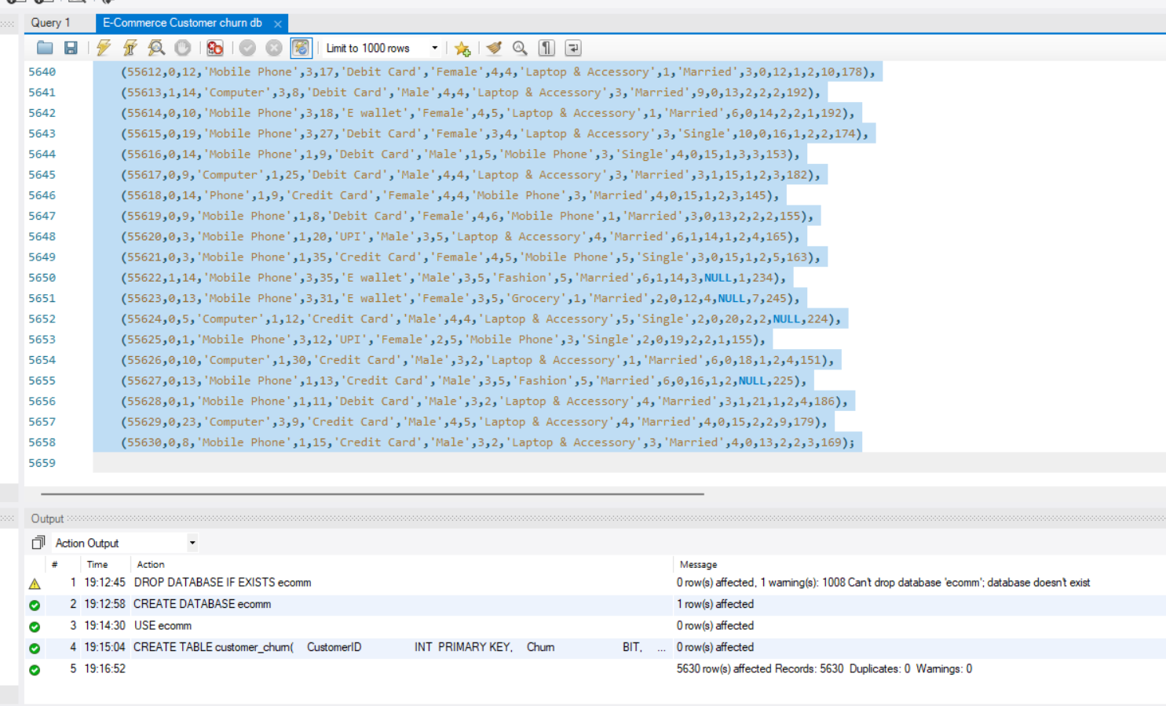
To Verify
SELECT * FROM customer_churn;
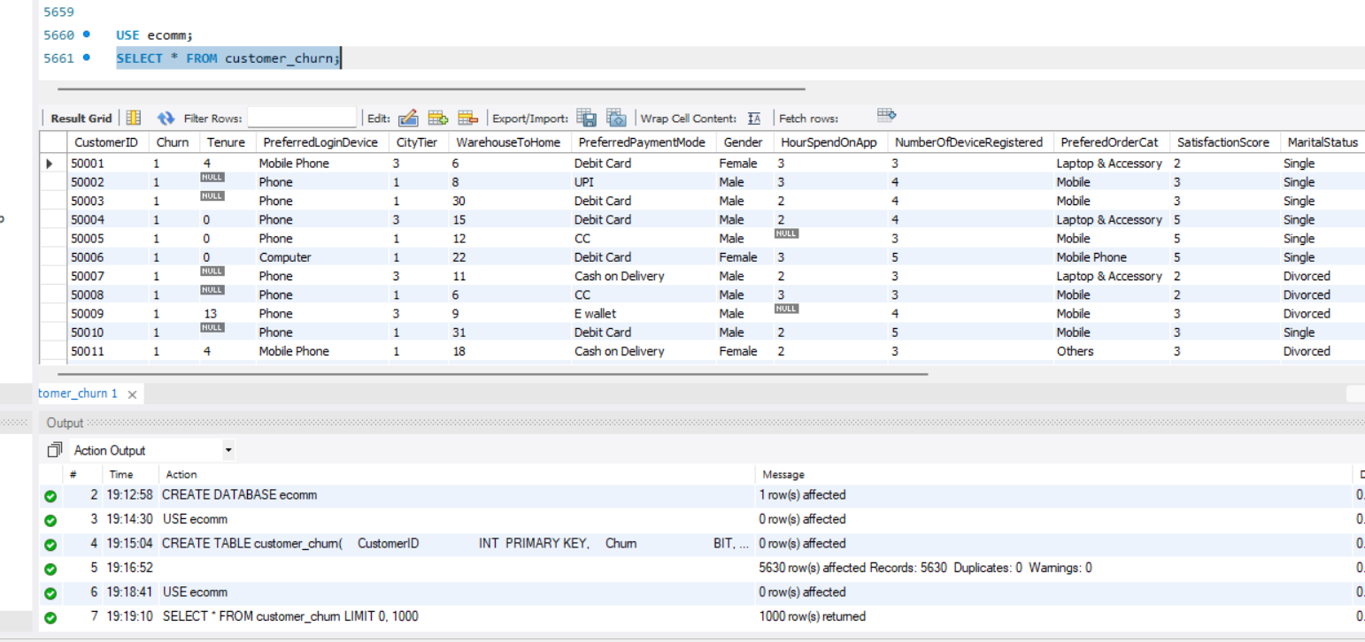

SELECT COUNT(*) AS Total_Customers
FROM customer_churn;

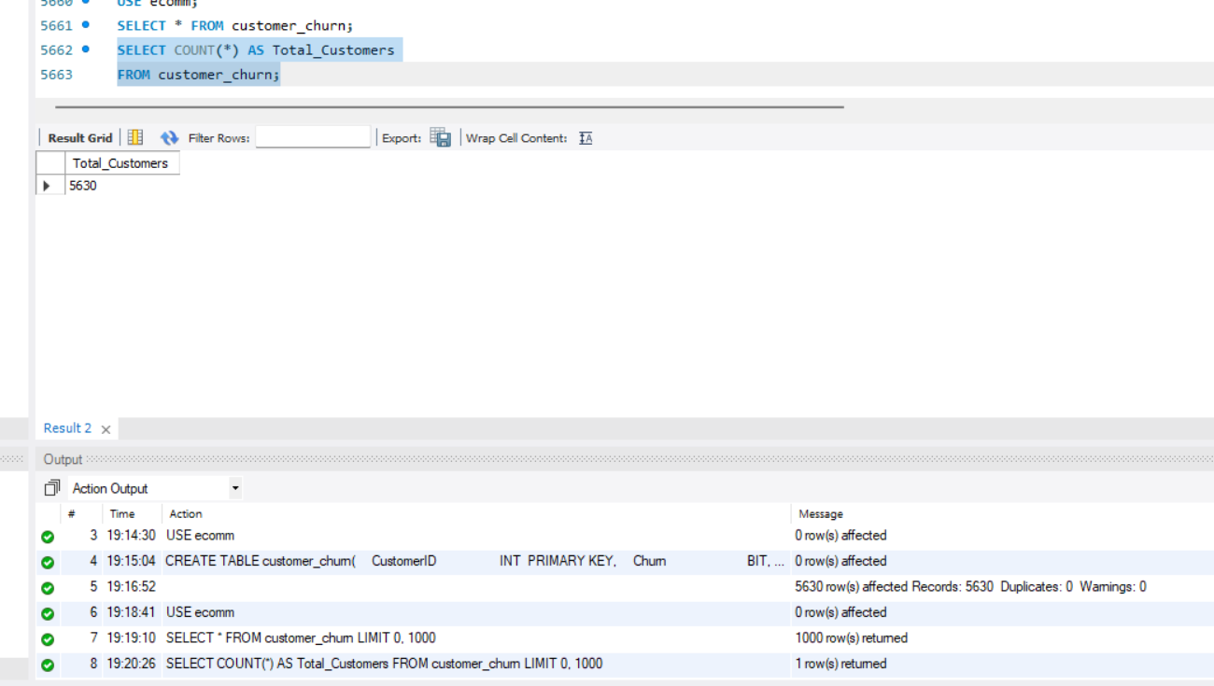

DESCRIBE customer_churn;
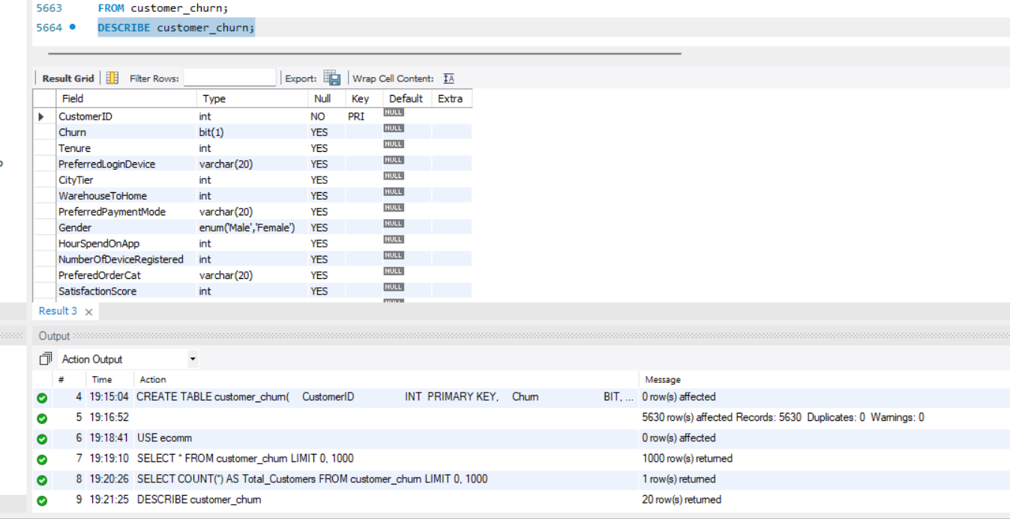

Project Steps and Objectives:
Data Cleaning: (5 marks)
Handling Missing Values and Outliers:
➢ Impute mean for the following columns, and round off to the nearest integer if required: WarehouseToHome, HourSpendOnApp, OrderAmountHikeFromlastYear, DaySinceLastOrder.
USE ecomm;
SELECT
COUNT(*) AS Total_Rows,
SUM(WarehouseToHome IS NULL) AS WarehouseToHome_Null,
SUM(HourSpendOnApp IS NULL) AS HourSpendOnApp_Null,
SUM(OrderAmountHikeFromlastYear IS NULL) AS OrderAmountHike_Null,
SUM(DaySinceLastOrder IS NULL) AS DaySinceLastOrder_Null
FROM customer_churn;
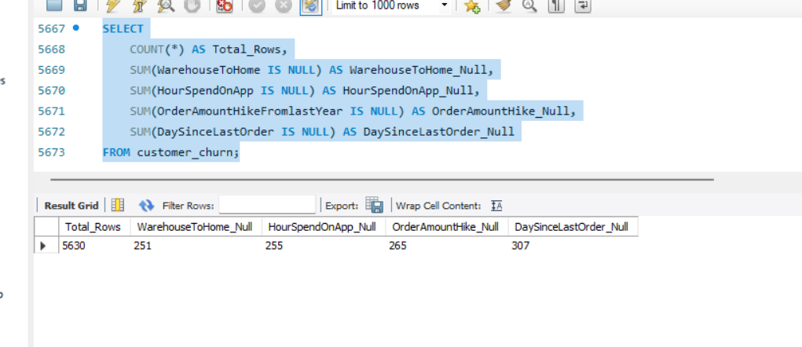
Before filling the missing values, calculate the average of each column.
SELECT
ROUND(AVG(WarehouseToHome), 0) AS Mean_WarehouseToHome,
ROUND(AVG(HourSpendOnApp), 0) AS Mean_HourSpendOnApp,
ROUND(AVG(OrderAmountHikeFromlastYear), 0) AS Mean_OrderAmountHike,
ROUND(AVG(DaySinceLastOrder), 0) AS Mean_DaySinceLastOrder
FROM customer_churn;
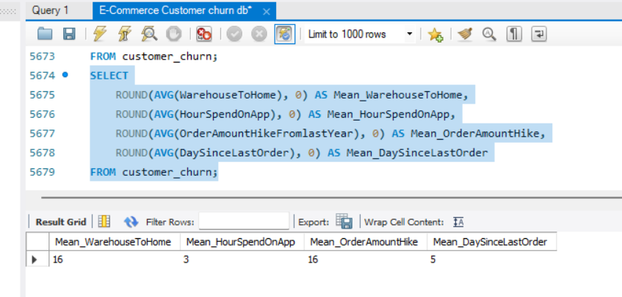
Replace NULL values with mean values
UPDATE customer_churn
SET
WarehouseToHome = COALESCE(WarehouseToHome, 16),
HourSpendOnApp = COALESCE(HourSpendOnApp, 3),
OrderAmountHikeFromlastYear =
COALESCE(OrderAmountHikeFromlastYear, 16),
DaySinceLastOrder = COALESCE(DaySinceLastOrder, 5)
WHERE CustomerID > 0
AND (
WarehouseToHome IS NULL
OR HourSpendOnApp IS NULL
OR OrderAmountHikeFromlastYear IS NULL
OR DaySinceLastOrder IS NULL
);
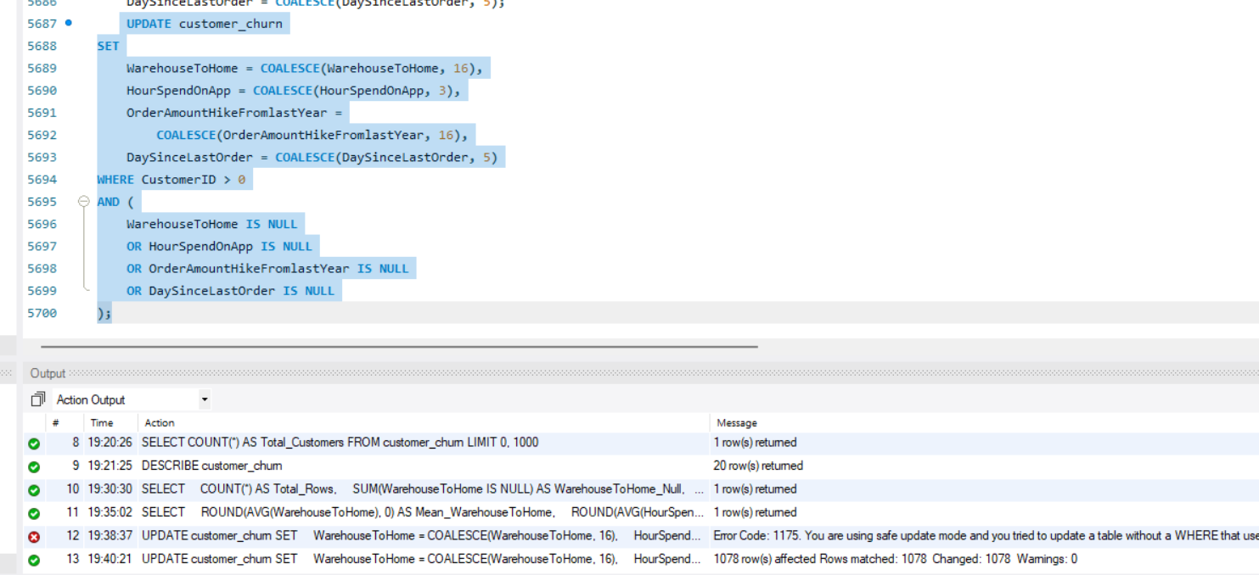
Verify the result
SELECT
SUM(WarehouseToHome IS NULL) AS WarehouseToHome_Null,
SUM(HourSpendOnApp IS NULL) AS HourSpendOnApp_Null,
SUM(OrderAmountHikeFromlastYear IS NULL) AS OrderAmountHike_Null,
SUM(DaySinceLastOrder IS NULL) AS DaySinceLastOrder_Null
FROM customer_churn;
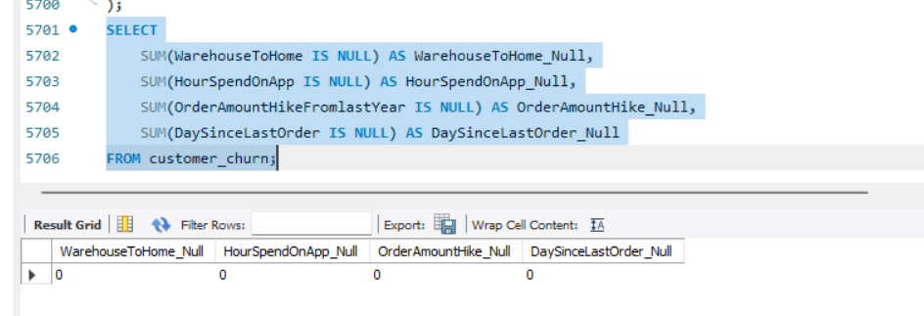
➢ Impute mode for the following columns: Tenure, CouponUsed, OrderCount.
Find the MODE of Tenure
SELECT
Tenure,
COUNT(*) AS Frequency
FROM customer_churn
WHERE Tenure IS NOT NULL
GROUP BY Tenure
ORDER BY Frequency DESC
LIMIT 1;
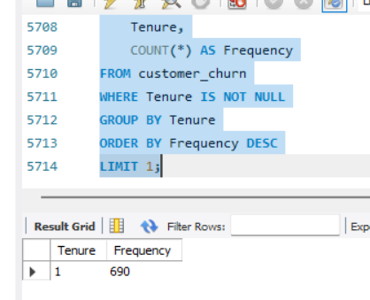
Replace the value
UPDATE customer_churn
SET Tenure = 1
WHERE Tenure IS NULL
AND CustomerID > 0;
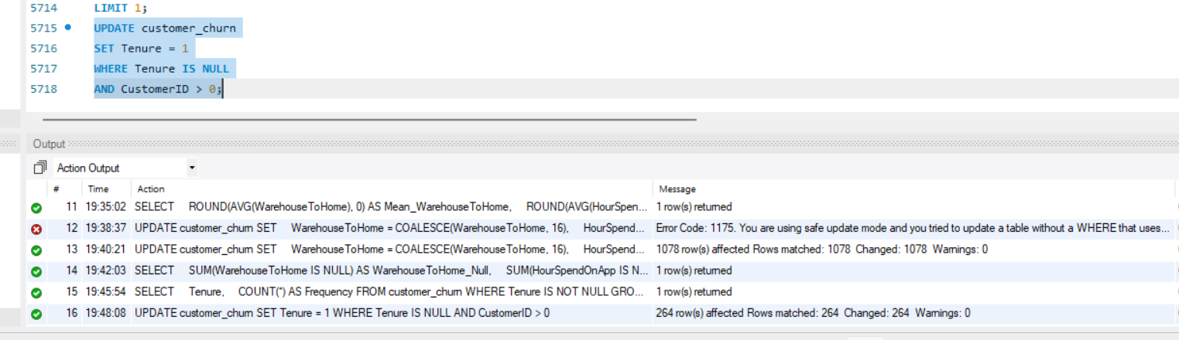
Find MODE of Coupon Used
SELECT
CouponUsed,
COUNT(*) AS Frequency
FROM customer_churn
WHERE CouponUsed IS NOT NULL
GROUP BY CouponUsed
ORDER BY Frequency DESC
LIMIT 1;
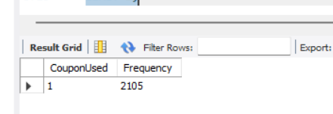
UPDATE customer_churn
SET CouponUsed = 1
WHERE CouponUsed IS NULL
AND CustomerID > 0;
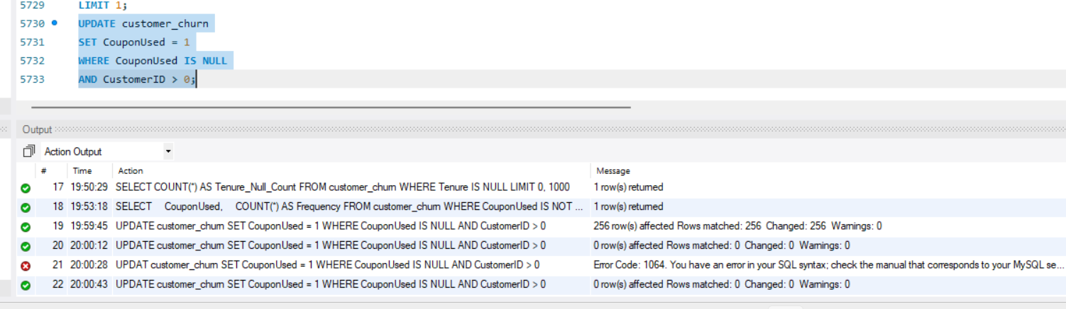

To Find MODE of Order Count
SELECT
OrderCount,
COUNT(*) AS Frequency
FROM customer_churn
WHERE OrderCount IS NOT NULL
GROUP BY OrderCount
ORDER BY Frequency DESC
LIMIT 1;
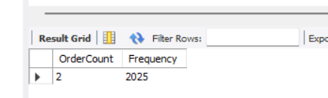

UPDATE customer_churn
SET OrderCount = 2
WHERE OrderCount IS NULL
AND CustomerID > 0;
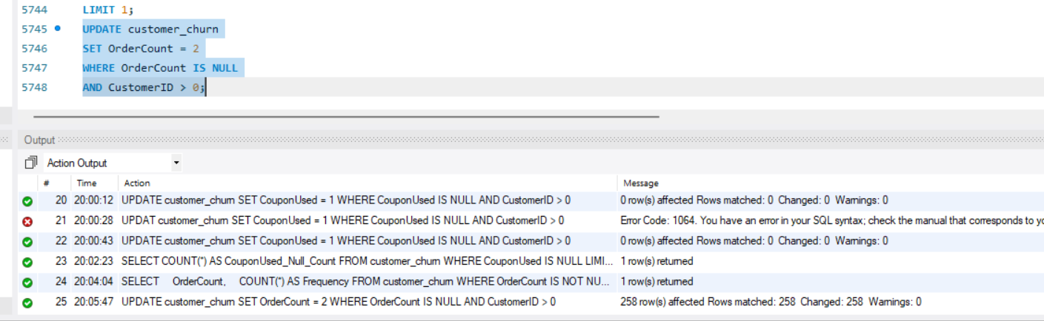
Verify
SELECT
SUM(Tenure IS NULL) AS Tenure_Null,
SUM(CouponUsed IS NULL) AS CouponUsed_Null,
SUM(OrderCount IS NULL) AS OrderCount_Null
FROM customer_churn;
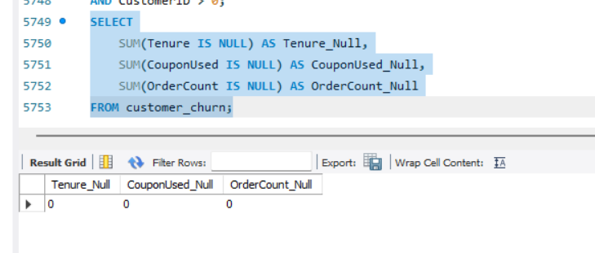
➢ Handle outliers in the 'WarehouseToHome' column by deleting rows where the values are greater than 100.
SELECT COUNT(*) AS Records_To_Delete
FROM customer_churn
WHERE WarehouseToHome > 100;
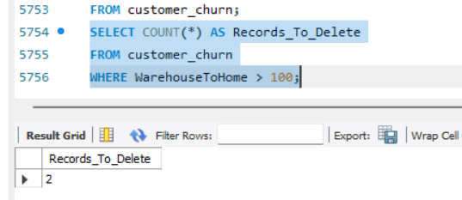
DELETE FROM customer_churn
WHERE WarehouseToHome > 100
AND CustomerID > 0;
Verify
SELECT COUNT(*) AS Remaining_Invalid_Records
FROM customer_churn
WHERE WarehouseToHome > 100;
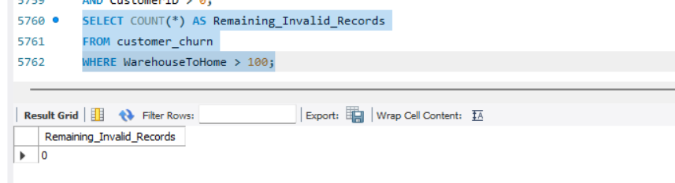
Dealing with Inconsistencies:
➢ Replace occurrences of “Phone” in the 'PreferredLoginDevice' column and “Mobile” in the 'PreferedOrderCat' column with “Mobile Phone” to ensure uniformity.
SELECT
PreferredLoginDevice,
COUNT(*) AS Customer_Count
FROM customer_churn
GROUP BY PreferredLoginDevice;
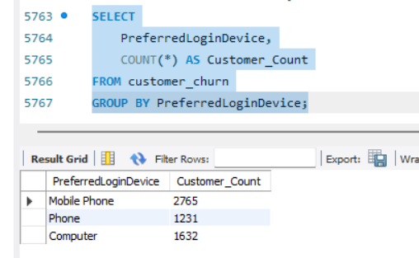
Standardize the value
UPDATE customer_churn
SET PreferredLoginDevice = 'Mobile Phone'
WHERE PreferredLoginDevice = 'Phone'
AND CustomerID > 0;
Verify
SELECT DISTINCT PreferredLoginDevice
FROM customer_churn;
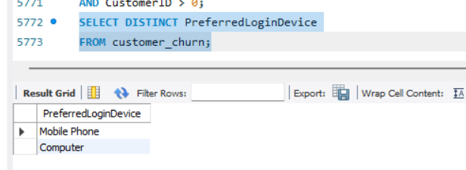
SELECT
PreferedOrderCat,
COUNT(*) AS Customer_Count
FROM customer_churn
GROUP BY PreferedOrderCat;
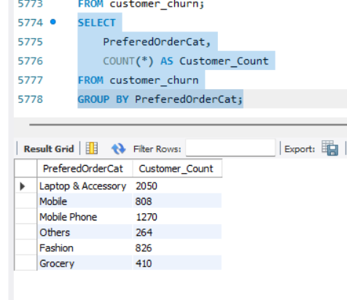
UPDATE customer_churn
SET PreferedOrderCat = 'Mobile Phone'
WHERE PreferedOrderCat = 'Mobile'
AND CustomerID > 0;
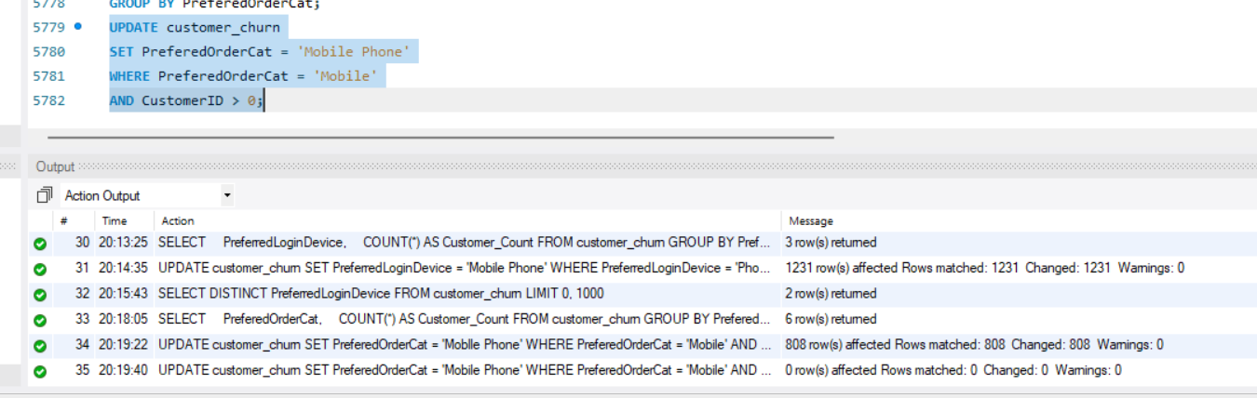
Verify
SELECT DISTINCT PreferedOrderCat
FROM customer_churn;
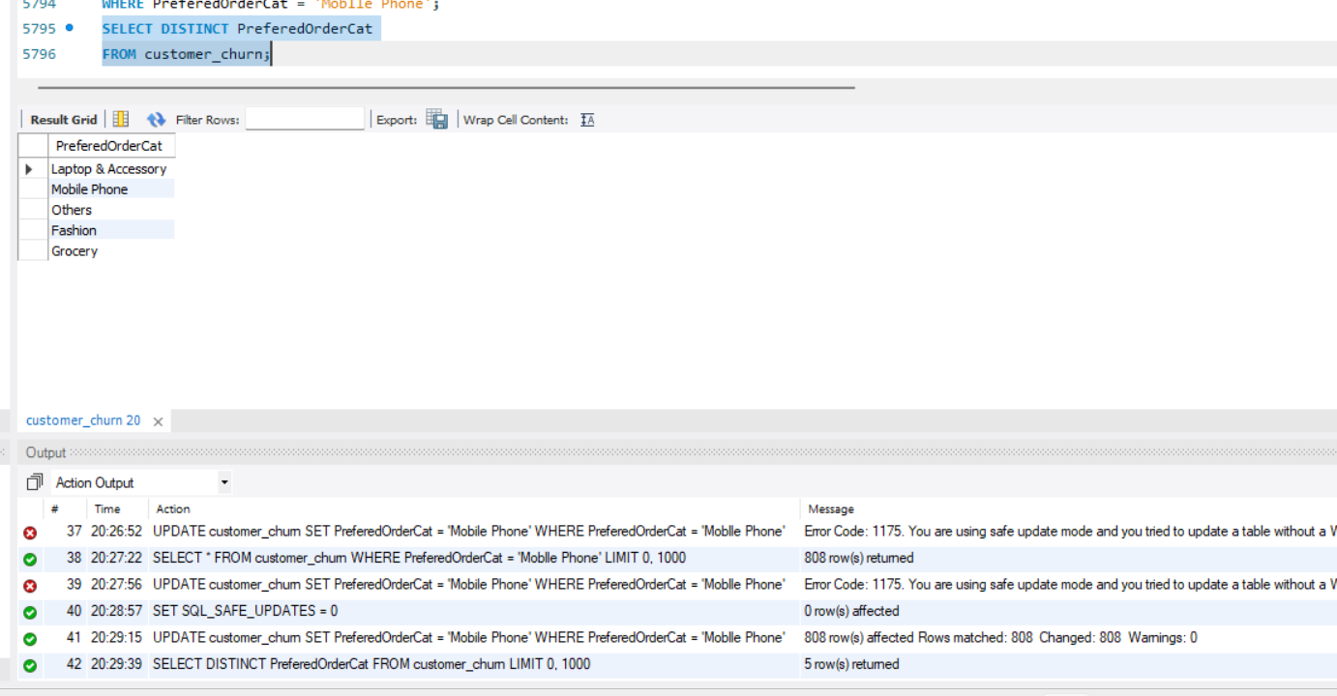
➢ Standardize payment mode values: Replace "COD" with "Cash on Delivery" and "CC" with "Credit Card" in the PreferredPaymentMode column.
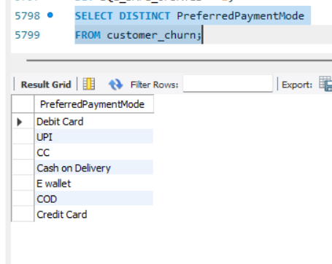
Correct CC to Credit Card
UPDATE customer_churn
SET PreferredPaymentMode = 'Credit Card'
WHERE PreferredPaymentMode = 'CC';
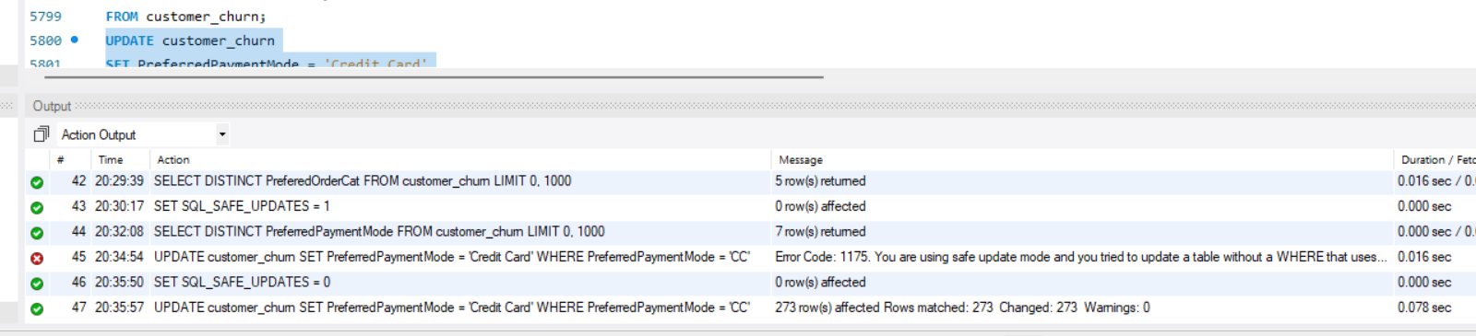
Correct COD to Cash on Delivery
UPDATE customer_churn
SET PreferredPaymentMode = 'Cash on Delivery'
WHERE PreferredPaymentMode = 'COD';
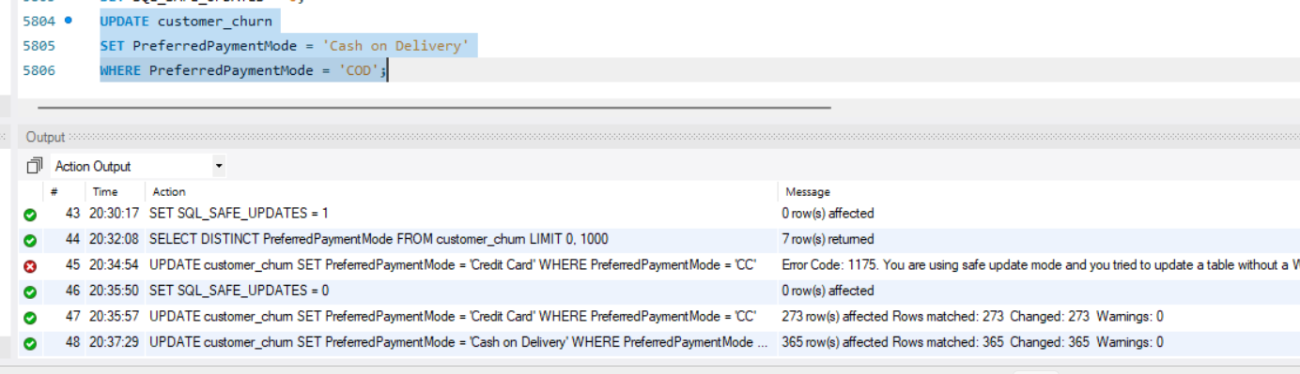
Verify
SELECT DISTINCT PreferredPaymentMode
FROM customer_churn;
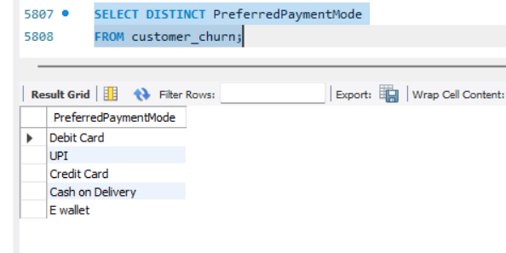
Data Transformation: (3 marks)
Column Renaming:
➢ Rename the column "PreferedOrderCat" to "PreferredOrderCat".
ALTER TABLE customer_churn
RENAME COLUMN PreferedOrderCat TO PreferredOrderCat;
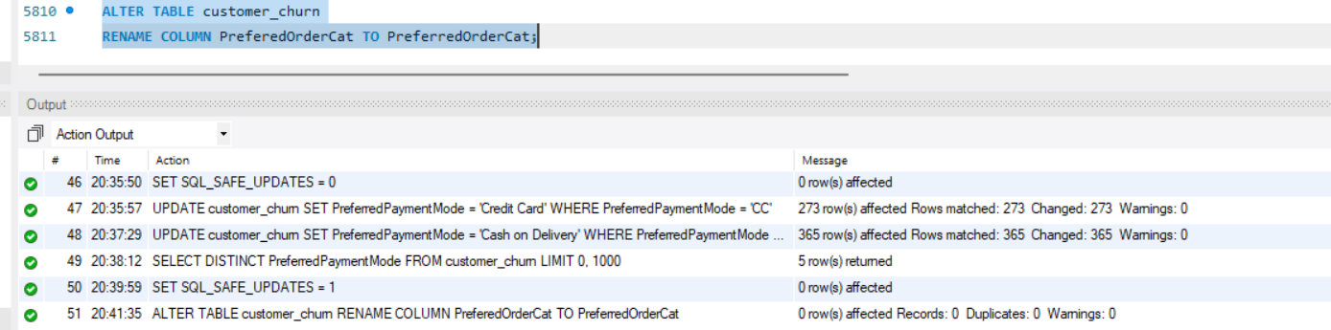
➢ Rename the column "HourSpendOnApp" to "HoursSpentOnApp".
ALTER TABLE customer_churn
RENAME COLUMN HourSpendOnApp TO HoursSpentOnApp;
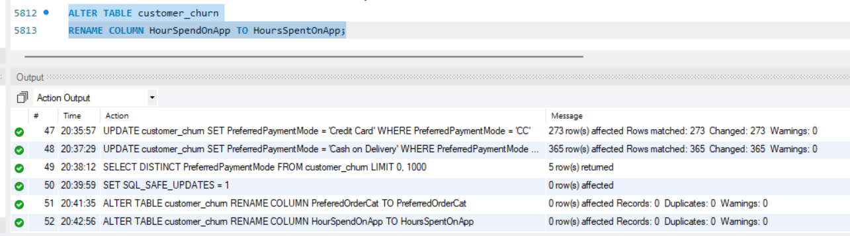
Creating New Columns:
➢ Create a new column named ‘ComplaintReceived’ with values "Yes" if the corresponding value in the ‘Complain’ is 1, and "No" otherwise.
ALTER TABLE customer_churn
ADD COLUMN ComplaintReceived VARCHAR(3);
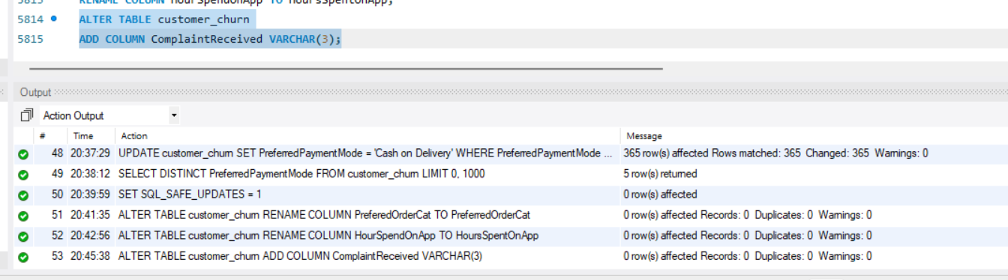
UPDATE customer_churn
SET ComplaintReceived =
CASE
WHEN Complain = 1 THEN 'Yes'
ELSE 'No'
END;
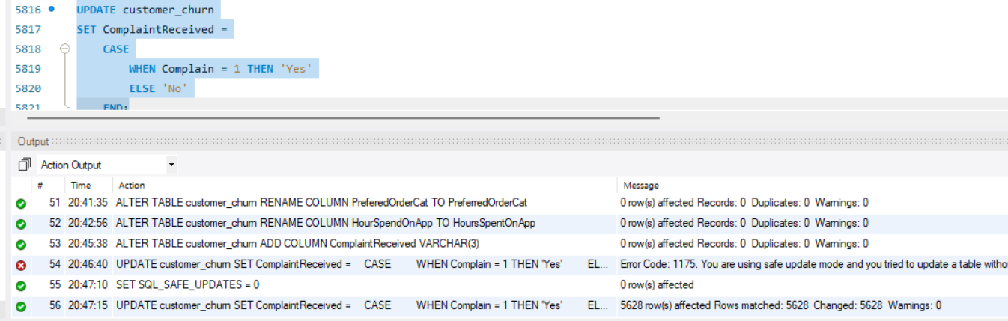
Verify
SELECT ComplaintReceived, COUNT(*) AS TotalCustomers
FROM customer_churn
GROUP BY ComplaintReceived;
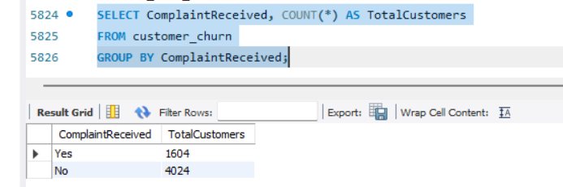
➢ Create a new column named 'ChurnStatus'. Set its value to “Churned” if the corresponding value in the 'Churn' column is 1, else assign “Active”.
ALTER TABLE customer_churn
ADD COLUMN ChurnStatus VARCHAR(10);
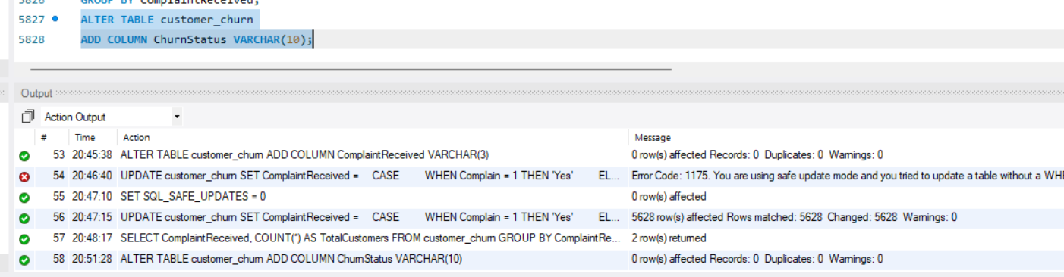
UPDATE customer_churn
SET ChurnStatus =
CASE
WHEN Churn = 1 THEN 'Churned'
ELSE 'Active'
END;
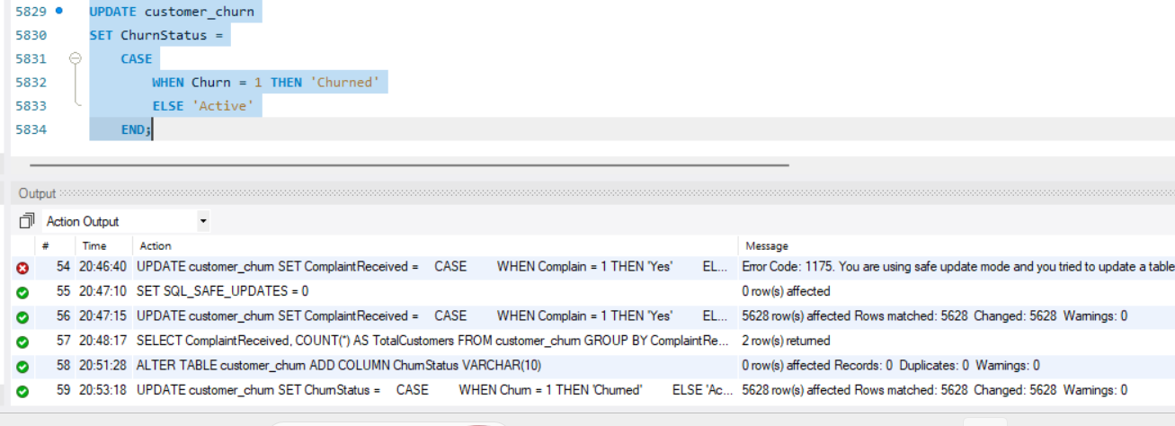
Verify
SELECT ChurnStatus, COUNT(*) AS TotalCustomers
FROM customer_churn
GROUP BY ChurnStatus;
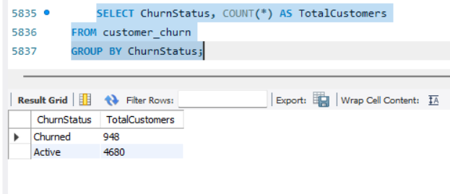
Column Dropping:
➢ Drop the columns "Churn" and "Complain" from the table.
ALTER TABLE customer_churn
DROP COLUMN Churn,
DROP COLUMN Complain;
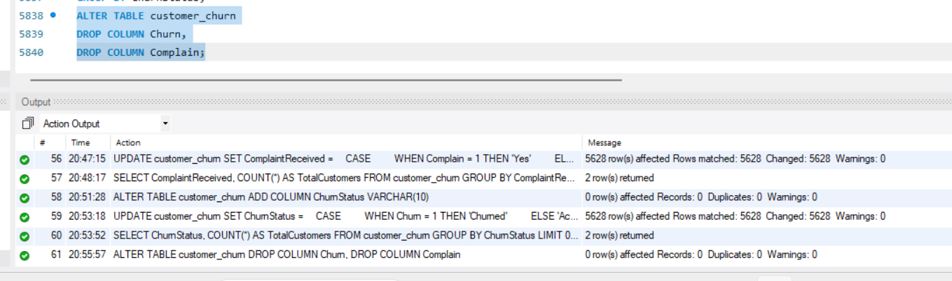
Verify
DESCRIBE customer_churn;
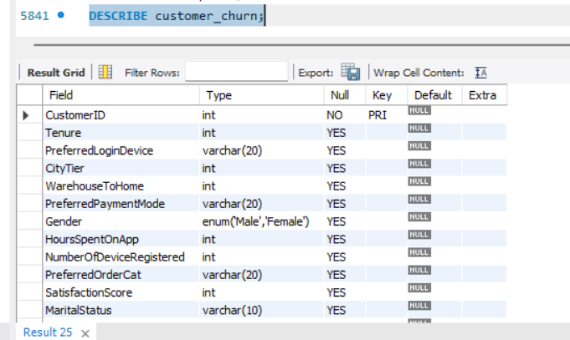
Data Exploration and Analysis: (17 marks)
➢ Retrieve the count of churned and active customers from the dataset.
SELECT
ChurnStatus,
COUNT(*) AS TotalCustomers
FROM customer_churn
GROUP BY ChurnStatus;
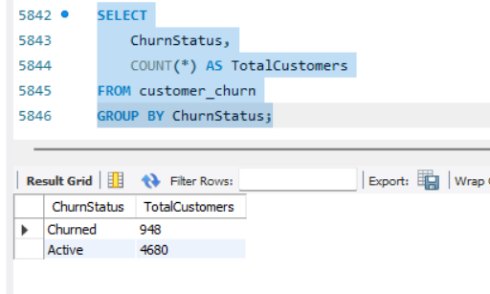
➢ Display the average tenure and total cashback amount of customers who churned.
SELECT
AVG(Tenure) AS AverageTenure,
SUM(CashbackAmount) AS TotalCashback
FROM customer_churn
WHERE ChurnStatus = 'Churned';
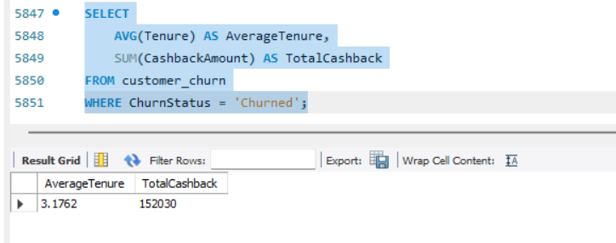
➢ Determine the percentage of churned customers who complained.
SELECT
ROUND(
SUM(CASE
WHEN ComplaintReceived = 'Yes' THEN 1
ELSE 0
END) * 100.0 / COUNT(*),
2
) AS ComplaintPercentage
FROM customer_churn
WHERE ChurnStatus = 'Churned';
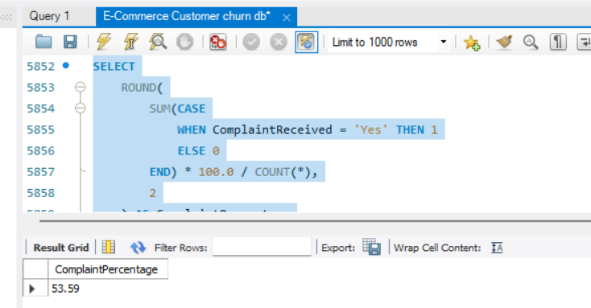
➢ Identify the city tier with the highest number of churned customers whose preferred order category is Laptop & Accessory.
SELECT
CityTier,
COUNT(*) AS ChurnedCustomers
FROM customer_churn
WHERE ChurnStatus = 'Churned'
AND PreferredOrderCat = 'Laptop & Accessory'
GROUP BY CityTier
ORDER BY ChurnedCustomers DESC
LIMIT 1;
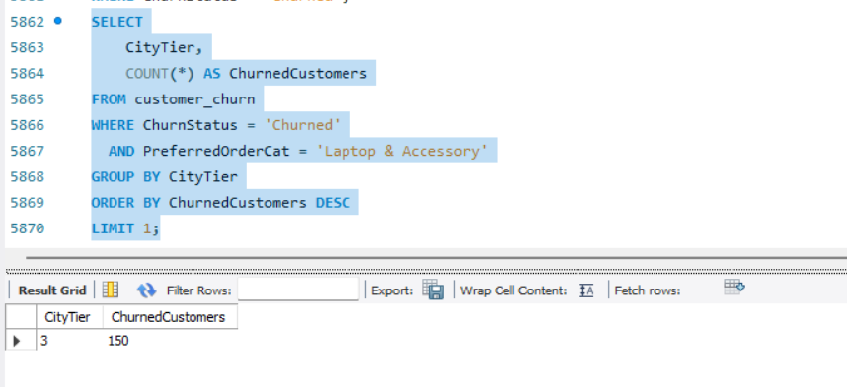
➢ Identify the most preferred payment mode among active customers.
SELECT
PreferredPaymentMode,
COUNT(*) AS TotalCustomers
FROM customer_churn
WHERE ChurnStatus = 'Active'
GROUP BY PreferredPaymentMode
ORDER BY TotalCustomers DESC
LIMIT 1;
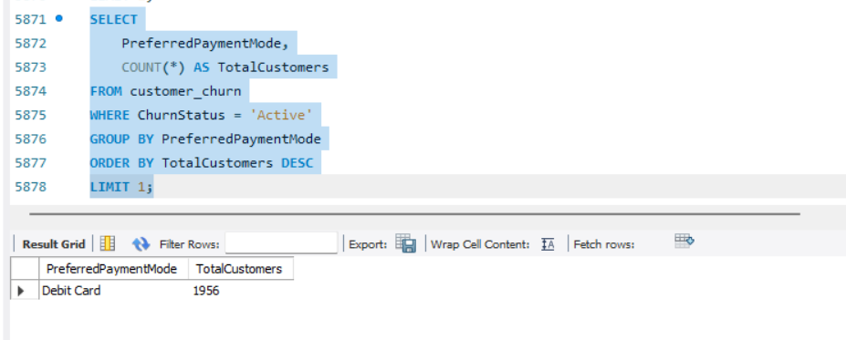
➢ Calculate the total order amount hike from last year for customers who are single and prefer mobile phones for ordering.
SELECT
SUM(OrderAmountHikeFromlastYear) AS TotalOrderAmountHike
FROM customer_churn
WHERE MaritalStatus = 'Single'
AND PreferredOrderCat = 'Mobile Phone';
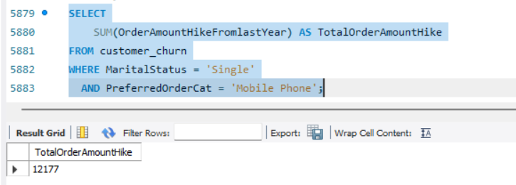
➢ Find the average number of devices registered among customers who used UPI as their preferred payment mode.
SELECT
AVG(NumberOfDeviceRegistered) AS AverageDevicesRegistered
FROM customer_churn
WHERE PreferredPaymentMode = 'UPI';
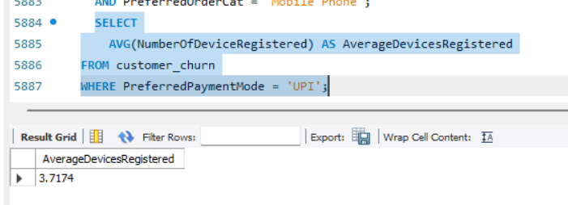
➢ Determine the city tier with the highest number of customers.
SELECT
CityTier,
COUNT(*) AS TotalCustomers
FROM customer_churn
GROUP BY CityTier
ORDER BY TotalCustomers DESC
LIMIT 1;
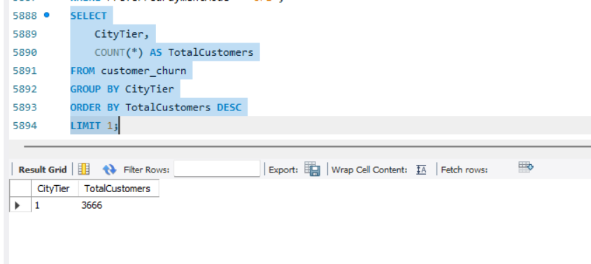

➢ Identify the gender that utilized the highest number of coupons.
SELECT
Gender,
SUM(CouponUsed) AS TotalCouponsUsed
FROM customer_churn
GROUP BY Gender
ORDER BY TotalCouponsUsed DESC
LIMIT 1;
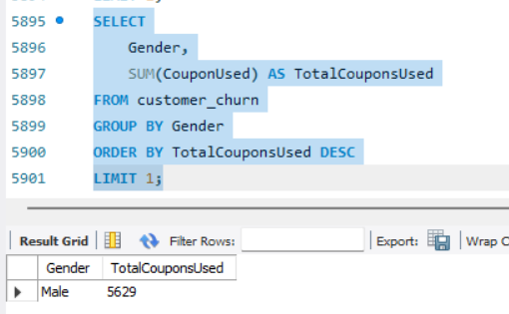
➢ List the number of customers and the maximum hours spent on the app in each preferred order category.
SELECT
PreferredOrderCat,
COUNT(*) AS TotalCustomers,
MAX(HoursSpentOnApp) AS MaxHoursSpentOnApp
FROM customer_churn
GROUP BY PreferredOrderCat;
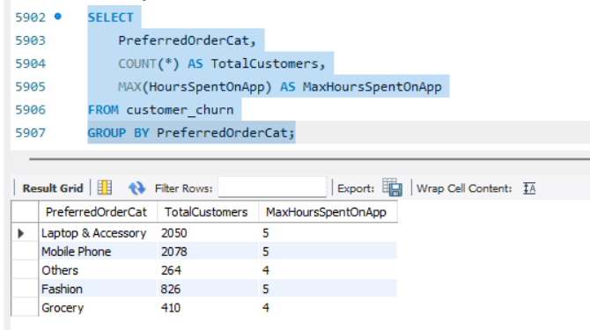
➢ Calculate the total order count for customers who prefer using credit cards and have the maximum satisfaction score.
SELECT
SUM(OrderCount) AS TotalOrderCount
FROM customer_churn
WHERE PreferredPaymentMode = 'Credit Card'
AND SatisfactionScore = (
SELECT MAX(SatisfactionScore)
FROM customer_churn
);
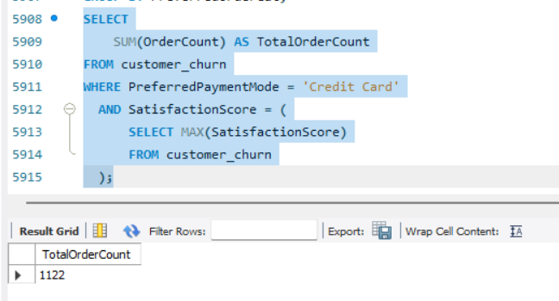
➢ What is the average satisfaction score of customers who have complained?
SELECT
AVG(SatisfactionScore) AS AverageSatisfactionScore
FROM customer_churn
WHERE ComplaintReceived = 'Yes';
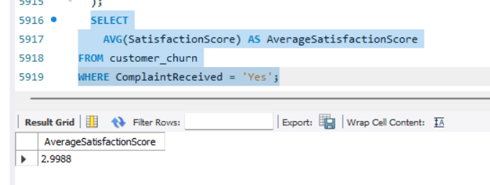
➢ List the preferred order category among customers who used more than 5 coupons.
SELECT
PreferredOrderCat,
COUNT(*) AS TotalCustomers
FROM customer_churn
WHERE CouponUsed > 5
GROUP BY PreferredOrderCat
ORDER BY TotalCustomers DESC;
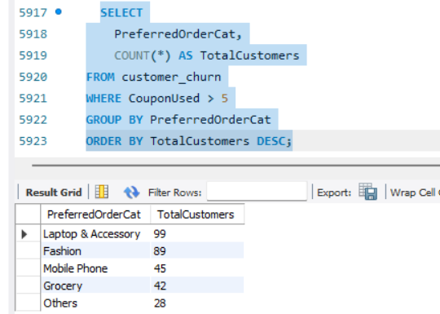
➢ List the top 3 preferred order categories with the highest average cashback amount.
SELECT
PreferredOrderCat,
ROUND(AVG(CashbackAmount), 2) AS AverageCashback
FROM customer_churn
GROUP BY PreferredOrderCat
ORDER BY AverageCashback DESC
LIMIT 3;
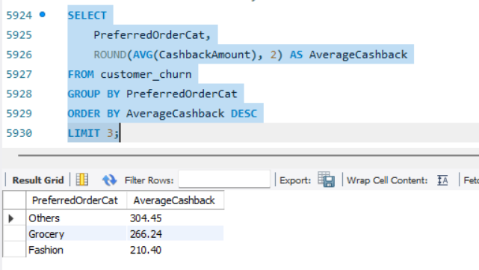
➢ Find the preferred payment modes of customers whose average tenure is 10 months and have placed more than 500 orders.
SELECT
PreferredPaymentMode,
AVG(Tenure) AS AverageTenure,
SUM(OrderCount) AS TotalOrders
FROM customer_churn
GROUP BY PreferredPaymentMode
HAVING AVG(Tenure) = 10
AND SUM(OrderCount) > 500;
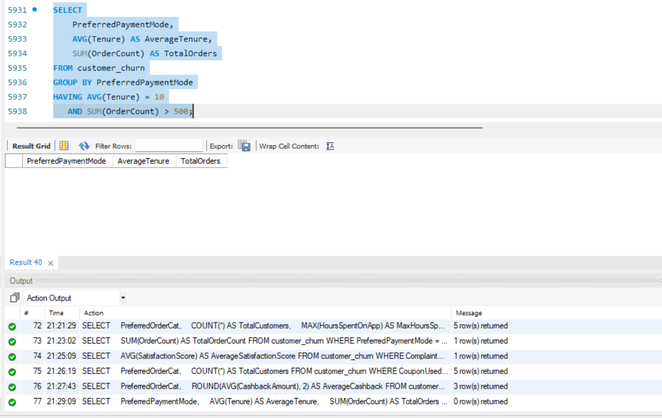

➢ Categorize customers based on their distance from the warehouse to home such as 'Very Close Distance' for distances <=5km, 'Close Distance' for <=10km, 'Moderate Distance' for <=15km, and 'Far Distance' for >15km. Then, display the churn status breakdown for each distance category.
SELECT
CASE
WHEN WarehouseToHome <= 5 THEN 'Very Close Distance'
WHEN WarehouseToHome <= 10 THEN 'Close Distance'
WHEN WarehouseToHome <= 15 THEN 'Moderate Distance'
WHEN WarehouseToHome > 15 THEN 'Far Distance'
END AS DistanceCategory,
ChurnStatus,
COUNT(*) AS TotalCustomers
FROM customer_churn
GROUP BY
DistanceCategory,
ChurnStatus
ORDER BY
CASE DistanceCategory
WHEN 'Very Close Distance' THEN 1
WHEN 'Close Distance' THEN 2
WHEN 'Moderate Distance' THEN 3
WHEN 'Far Distance' THEN 4
END,
ChurnStatus;
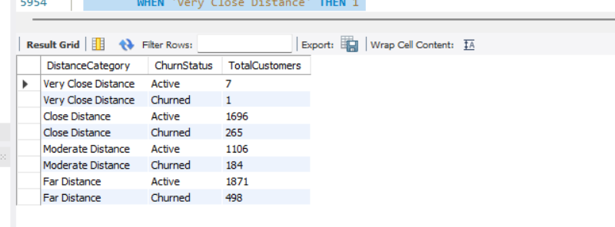
➢ List the customer’s order details who are married, live in City Tier-1, and their order counts are more than the average number of orders placed by all customers.
SELECT
CustomerID,
MaritalStatus,
CityTier,
OrderCount
FROM customer_churn
WHERE MaritalStatus = 'Married'
AND CityTier = 1
AND OrderCount > (
SELECT AVG(OrderCount)
FROM customer_churn
);
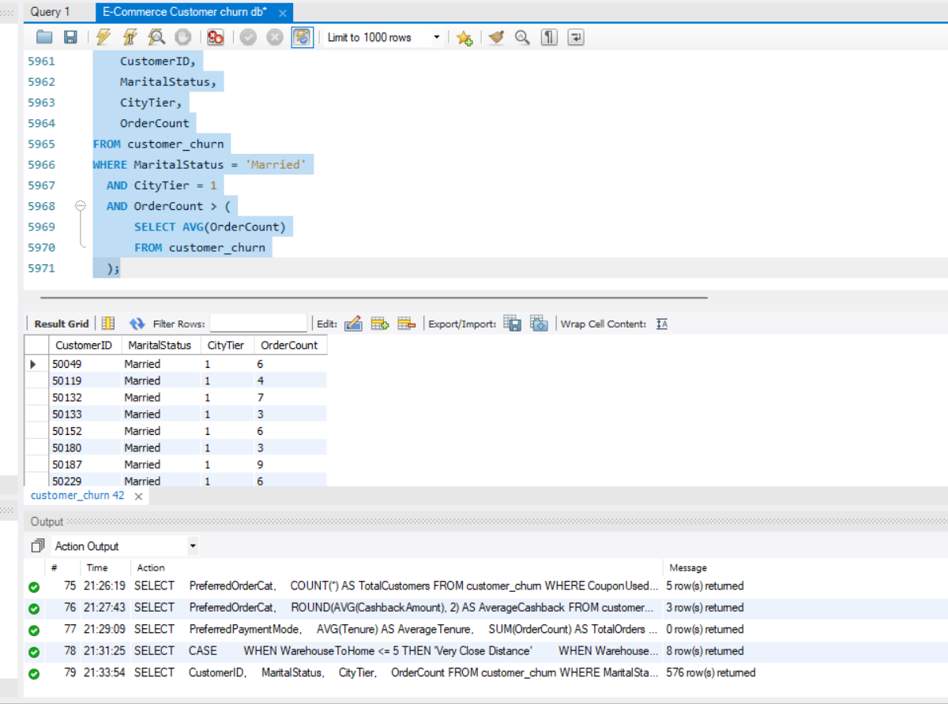
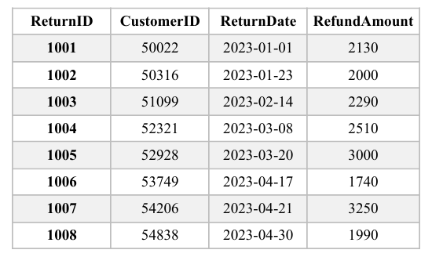
➢ a) Create a ‘customer_returns’ table in the ‘ecomm’ database and insert the following data:

USE ecomm;
CREATE TABLE customer_returns (
ReturnID INT PRIMARY KEY,
CustomerID INT,
ReturnDate DATE,
RefundAmount INT
);
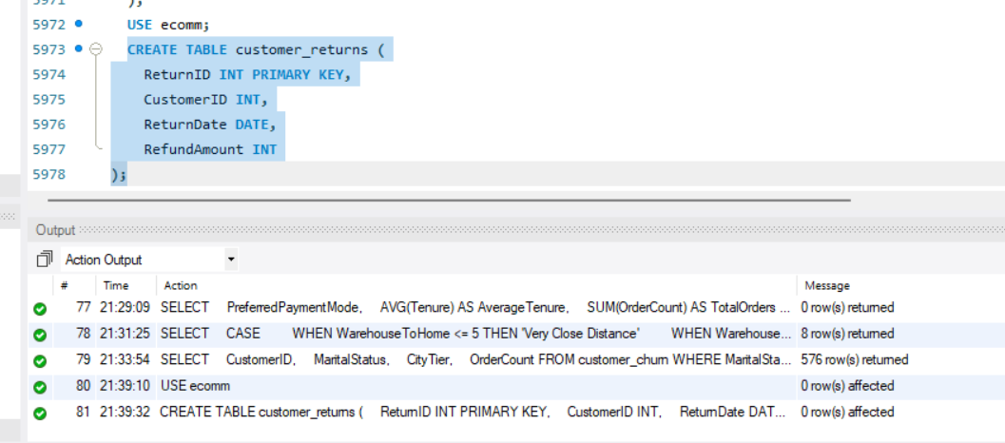

INSERT INTO customer_returns
(ReturnID, CustomerID, ReturnDate, RefundAmount)
VALUES
(1001, 50022, '2023-01-01', 2130),
(1002, 50316, '2023-01-23', 2000),
(1003, 51099, '2023-02-14', 2290),
(1004, 52321, '2023-03-08', 2510),
(1005, 52928, '2023-03-20', 1740),
(1006, 53749, '2023-04-17', 3000),
(1007, 54206, '2023-04-21', 1990),
(1008, 54838, '2023-04-30', 3250);
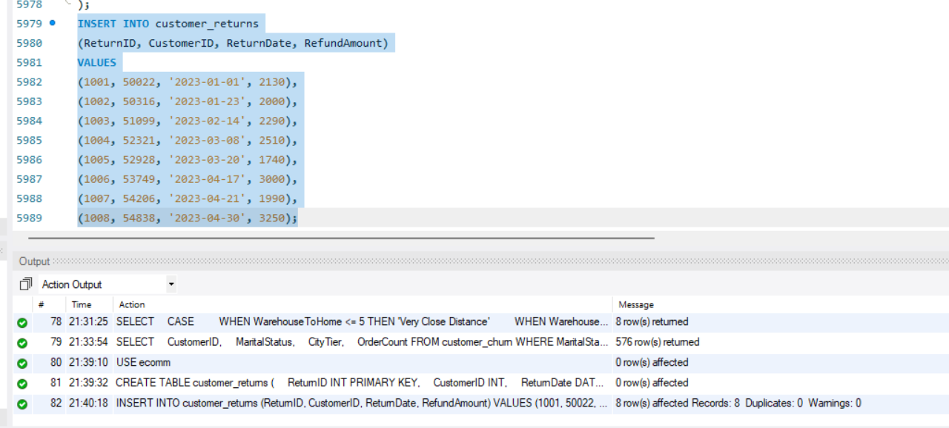
SELECT * FROM customer_returns;
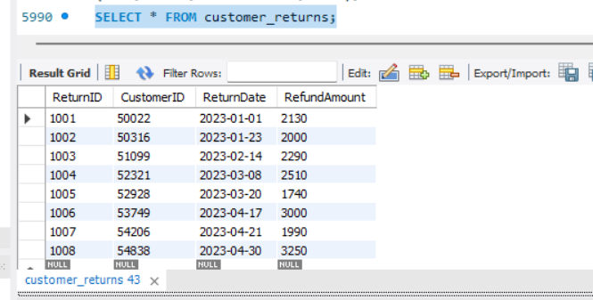
b) Display the return details along with the customer details of those who have churned and have made complaints.
SELECT
r.ReturnID,
r.CustomerID,
r.ReturnDate,
r.RefundAmount,
c.*
FROM customer_returns AS r
INNER JOIN customer_churn AS c
ON r.CustomerID = c.CustomerID
WHERE c.ChurnStatus = 'Churned'
AND c.ComplaintReceived = 'Yes';
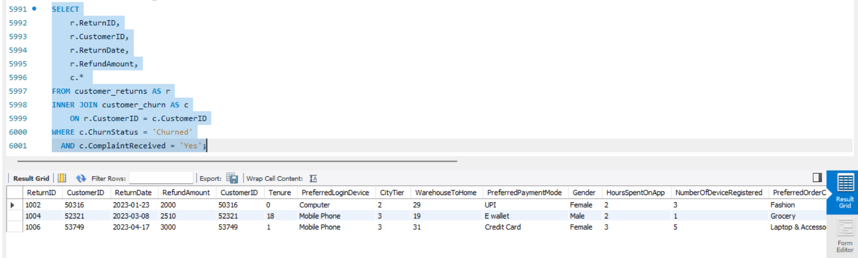
Completed the E-Commerce Customer Churn Analysis SQL Project

